PIZZA SALES SQL QUERIES

A.KPI’S

1.Total Revenue:



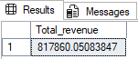

2.Average Order Value





3.Total Pizzas Sold





4.Total orders



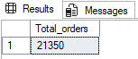

5.Average Pizzas per order

select cast(cast(sum(quantity) as decimal(10,2)) / cast(count(distinct order_id) as decimal(10,2)) as decimal(10,2)) as avg_pizza_per_order from pizza_sales



CHARTS REQUIREMENT

1.Daily trend for total orders:

select datename(DW, order_date) as order_day, count(distinct order_id) AS Total_orders from pizza_sales

group by datename(DW, order_date)

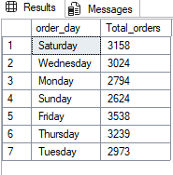

2.Monthly sales

select datename(month, order_date) as month_name, count(distinct order_id) as total_orders from pizza_sales

group by datename(month, order_date)

order by total_orders desc

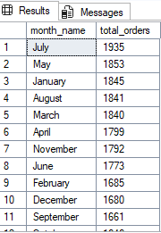

3.Percentage of sales by pizza category

select pizza_category, sum(total_price) * 100/ (select sum(total_price) from pizza_sales where month(order_date)=1)

as PCT from pizza_sales

where month(order_date)=1

group by pizza_category

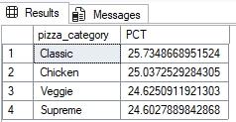

4.Percentage of sales by pizza size

select pizza_size, sum(total_price) as Total_sales, cast(sum(total_price) * 100 / (select sum(total_price) from pizza_sales)as decimal(10,2)) as pct

from pizza_sales

group by pizza_size

order by pct desc

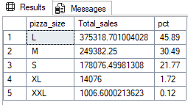

5.Top 5 pizza by revenue

select top 5 pizza_name, sum(total_price) as total_revenue from pizza_sales

group by pizza_name

order by total_revenue desc

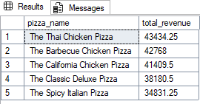

6. bottom 5 pizza

select top 5 pizza_name, sum(total_price) as total_revenue from pizza_sales

group by pizza_name

order by total_revenue asc

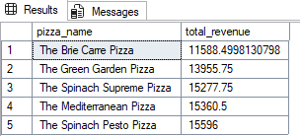

7.top pizza by order

select top 5 pizza_name, count(distinct order_id) as total_orders from pizza_sales

group by pizza_name

order by total_orders desc

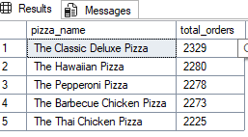

8.bottom pizza by order

select top 5 pizza_name, count(distinct order_id) as total_orders from pizza_sales

group by pizza_name

order by total_orders

